7/31/2017

**Analysis of World Soccer Contracts**

Social Network Analysis

Salman Mohammed 1001398053

Tapan Patel 1001450804

**Group Members**

**WORLD SOCER DATA PARIS 1998**

1. **Background**

The network data was collected from The Colorado Index of Complex Networks (ICON). The dataset describes the 22 soccer teams which participated in the World Championship in Paris, 1998.

Players of the national team often play for clubs in different countries. This constitutes a players’ market where national teams export players to other countries. Members of the 22 teams had contracts in altogether 35 countries.

Counting which team exports how many players to which country can be described with a valued, asymmetric graph. The graph is highly asymmetric: some countries only export players, some countries are only importers.

1. **Data Visualization**

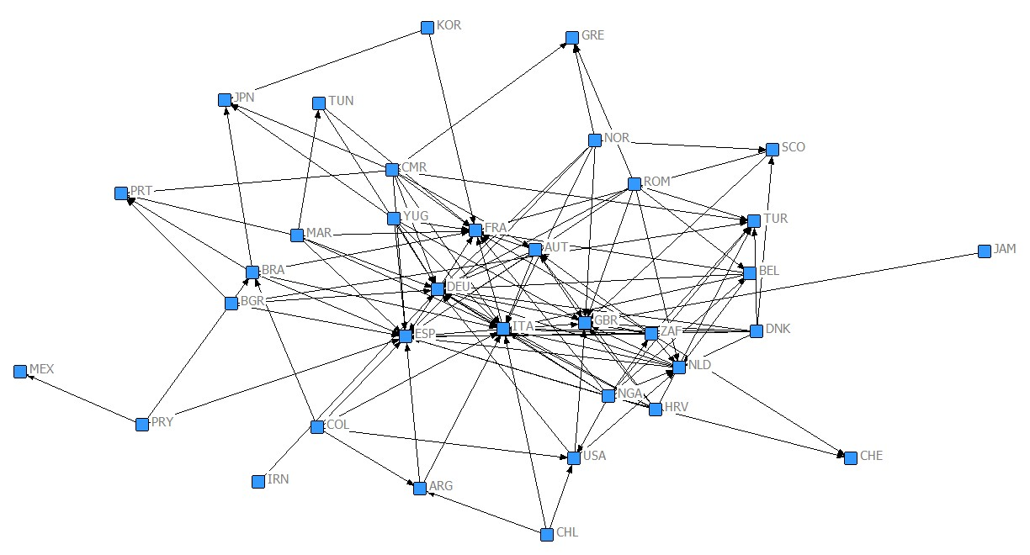**Net Draw Visualization**

It is clear from the above visualization of our network data that just the European countries like Spain, Great Britain, Italy, Germany, France, Portugal, Netherlands etc. have majority of the connections flowing into them. In the context of our dataset it means that these are the countries that were importing a lot of talented soccer players from other countries. This could be explained by a couple of facts. First, in 1998 (And still), which is the year our data was recorded in, the European countries were the powerhouse of football and their leagues had top standards and were religiously followed around the world (Still are), especially, countries like Spain, Italy, France and Great Britain. Second, these countries had the best players in the world playing in them, and, also had the financial resources to attract talented players from the other not so strong leagues. Naturally, every soccer player wanted to play in one of these top leagues. Other than the European leagues, the other countries importing a lot of players from other leagues were, Brazil and Japan. This can be explained by the fact that Brazil were the defending world champions and Japan were(are) one of the most successful soccer teams in Asia.

1. **Data matrix**

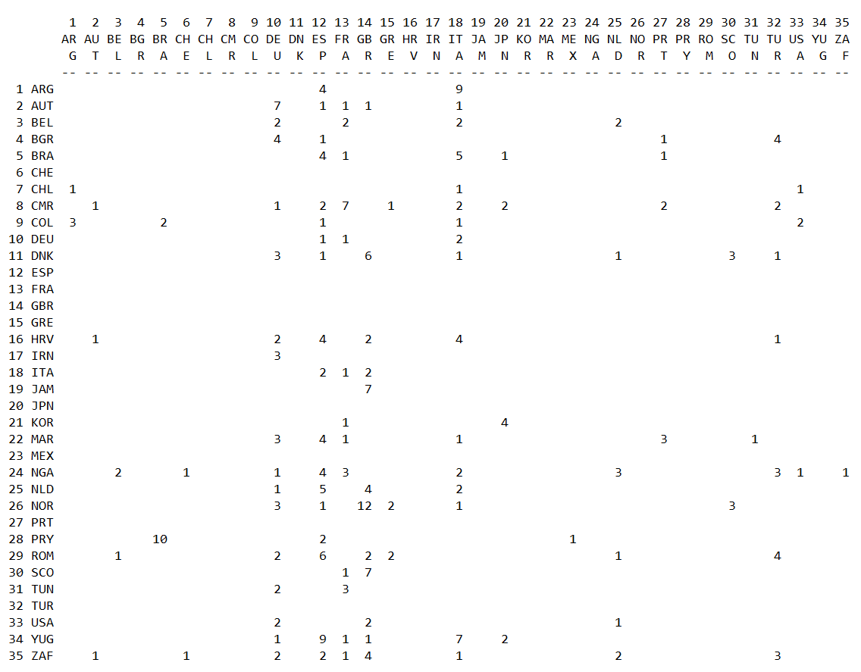

It can be seen from our data matrix that

* All the Brazil’s imports are from within the South American continent- namely from two countries Paraguay and Colombia. The South American players might prefer Brazilian league if they don’t get the chance to play in Europe. Especially, Paraguay, who has exported 10 players out of 13 to Brazil.
* The Argentinian footballers have been exported to only two countries as well, namely, Spain and Italy. 9 out of 13 players have gone to Italy. This could be because Italy was probably the best league in the world and the others have gone to Spain which was also one of the best leagues and, also, the language spoken there is Spanish, which is also what is spoken in Argentina. The players might feel they could easily settle into the life in Spain as they wouldn’t have a language barrier.
* Korea exported 4 out of 5 players to Japan. This might be explained by the fact that the culture in Japan, also an Asian country, is similar, to that in Korea. So, they would face less of a culture shock than if they moved to a European country.
* We can also see that all the European countries mostly export within the continent. This makes total sense as the quality and financial power of the European leagues is the best in the world. So, naturally, they would not want to move to another continent.

1. **IN and OUT degrees (with weights)**

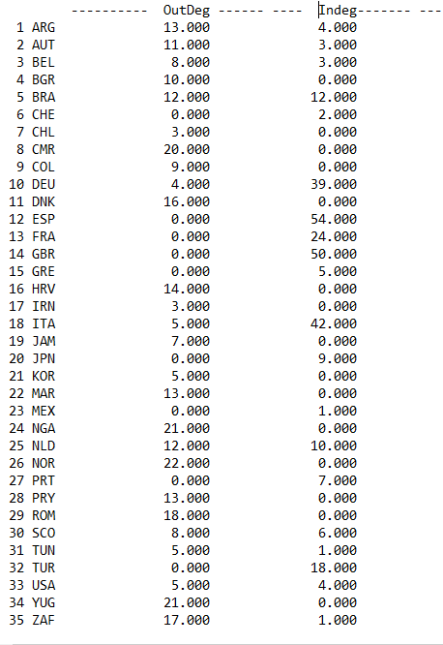

From the above diagram of in and out degrees (with weights), we can easily confirm our earlier observations that majority of the countries that have imported players from the leagues of other countries are from Europe. In fact, 7 out of 8 countries that have double digit In-degrees (which in our data set’s context means ‘imported players’) are from Europe. The only other country is Brazil, who were the world champions at the time. The only other country who comes close to a double digit In-degree is Japan with a value of 9.

We can see from the Out-degrees that Africa is one of the biggest exporters of players. The five African countries in our dataset, namely, Cameroon (CMR), Nigeria (NGR), South Africa (ZAF), Morocco (MAR)and Tunisia (TUN), together export 76 players and in contrast, import just 2 footballers (1 each by South Africa and Morocco).

1. **IN and OUT degrees (without weights)**

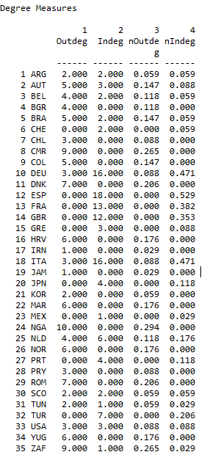

We can see from the above diagram of in and out degrees (without weights) that

* There are countries that only export: Nigeria, Cameroon, Romania, Norway…
* There are countries that only import: Spain, France, GBR…
* Spain imports players from 18 different countries, which is the most for any country, followed by Italy and Germany who import 16 each.
* Nigeria exports players to 10 different countries, which is the most for any country.

1. **Hubs & Authorities**

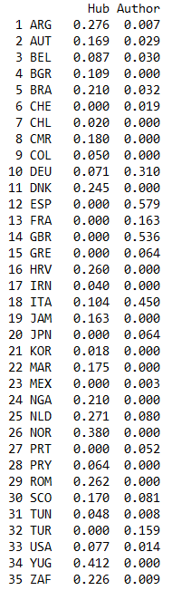

In the context of our data set, Hubs are countries having very good footballers and Authorities are countries having good leagues. In our data set,

* In descending order, the Authorities are: Spain (0.579), GBR (0.536), Italy (0.450), Germany (0.31), France (0.163), Turkey (0.159) …
* In descending order, the Hubs are: Yugoslavia, Norway, Argentina, Romania, Croatia, Denmark …
* Hubs and authorities: The Netherlands, Scotland, Brazil...

On comparing both the degree centrality and hubs and authorities, we realized that Nigeria is not an important hub, although it exports to 10 different countries (most for any country). We could explain this with two reasons:

* the fact that the degree centrality values in the diagram (the one without weights) are just the number of different countries where players are exported and not how many players, while this information is used to calculate hubs and authorities. If we look at the degrees with weights, Nigeria (21) is in the third place after Norway (22) and Yugoslavia (21).
* The second reason and probably the more important one is that Nigeria exports a much smaller proportion of its players to the best leagues in the world (also the Authorities) compared to the other countries like Norway and Yugoslavia.

It exports only 10 of its 21 (48%) footballers to the top leagues (in Spain, Italy, France, Germany and Great Britain). Whereas Yugoslavia exports 19 of its 20 (90%) players to these leagues and Norway exports 17 of its 22 (77%) players to these leagues.

Similarly, Argentina’s presence in the hubs also made us curious as it does not export many players (only 13). But after careful analysis, we observed that it exported players to just two countries, but these were the top leagues (also Authorities) in Spain and Italy.

1. **Hierarchical clustering**

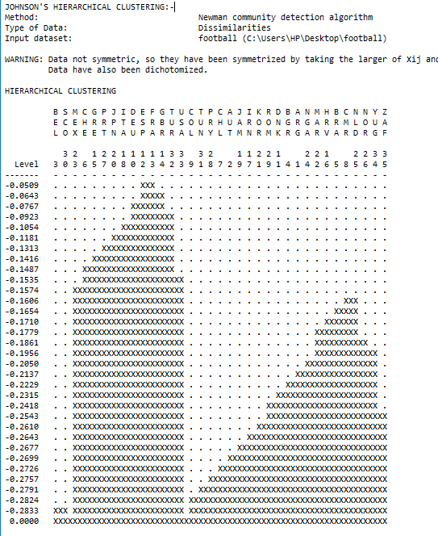

We can clearly see from the above clustering diagram that there are two distinct groups. One is of the importers like Italy, Spain, France, Germany, GBR and the other is of the exporters like Cameroon, Nigeria, Morocco, Norway, Yugoslavia, etc.

1. **Regular equivalence**

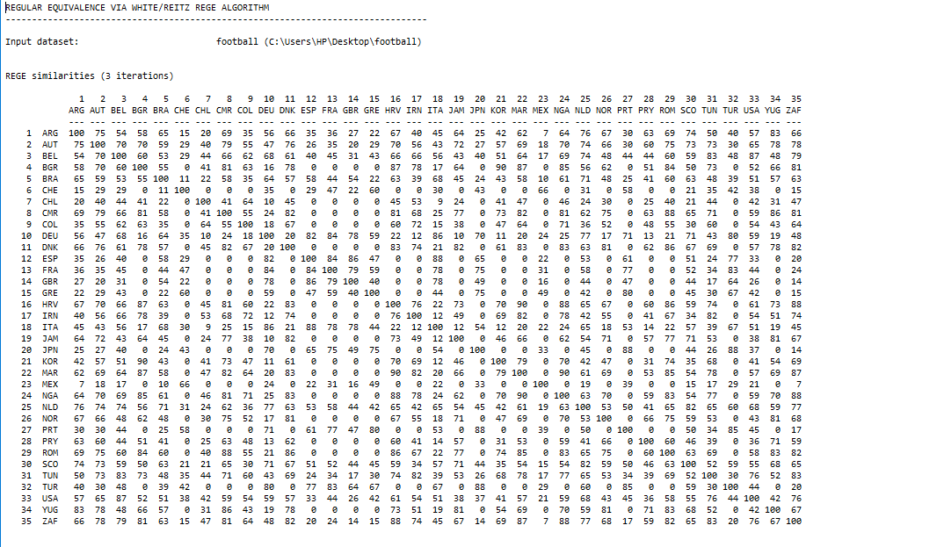

In the above diagram, we ran the Rege algorithm to get the regular equivalence and we can see that the exporters share high values with each other, indicating that they have similar profile and thus share a similar role. For example, Italy shares high values with the other exporters like Spain (88), Germany (86), France (78) and GBR (78). Similarly, importers share high values with each other. For example, Nigeria shares high values with other exporters like Morocco (90), South Africa (88) etc. Conversely, the exporters share low values with the importers and vice versa.

1. **Hierarchical Clustering of Equivalence Matrix.**

**(Regular Equivalence)**

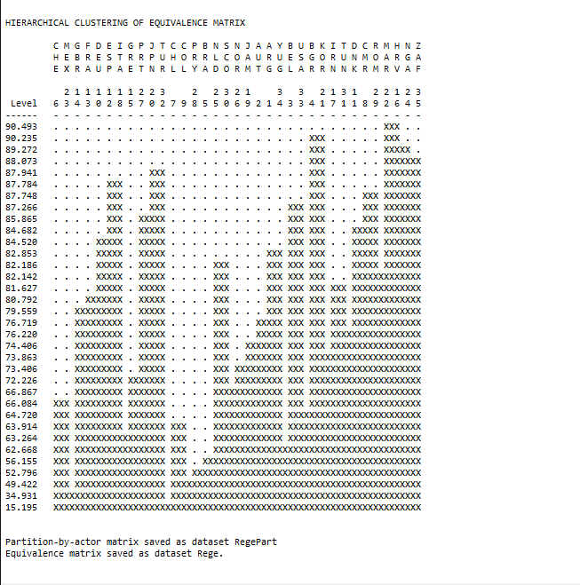

From the above clustering result of equivalence matrix, we can see on the left of the diagram that Spain and Italy are grouped together first. Then Germany joins the cluster, followed by France and then Great Britain. This is in line with our inference that these are big importers of Footballers, so they have similar roles in the network. Similarly, on the right of the diagram, we have all the exporters clustered together in small groups in the beginning and finally becoming one huge cluster. This also makes sense as they play similar roles of being importers.

1. **Non-metric MDS**



The above non-metric MDS diagram had a good stress value of 0.10. In the diagram, we can see that the importers like Spain, Italy, Germany, France, GBR are placed closed to each other. And the exporters like Nigeria, Morocco, Cameroon are also placed next to each other.

1. **Conclusion.**

From the data visualization, hierarchical clustering diagrams, non-metric MDS and other figures analyzed in our analysis, we can conclude by saying that there are essentially two types of countries- the predominant importers and the predominant exporters, with the exception, of a few countries like Brazil and Netherlands that fall under both categories (can be seen in the in and out degrees diagram). We can also conclude from the analysis that Europe is the biggest importer in the world, attracting the best players in the world from other countries. Another conclusion that can be made is that the European countries prefer exporting within the continent. Also, the results of the Hubs and Authorities procedure were in line with our other analysis, giving the expected Authorities (countries with the best leagues in the world and that are also the biggest importers) and Hubs (countries that have very good players and are big exporters). The regular equivalence results were also accurate, in that, the exporter countries shared high values with each other and low values with the importer countries and a similar pattern was observed in case of the importer countries.